Lab 2: Design and Analysis of a Power BI–Based Decision Support System (DSS) for Student Academic Outcomes

Objectives
- To analyze how lifestyle factors affect academic performance.
- To examine relationships between stress, sleep, physical activity, and grades.
- To compare student performance across gender and stress levels.
- To identify key habits associated with high academic achievement.
- To perform what-if analysis on changes in study, sleep, and social time.
- To design an interactive Power BI dashboard for decision support.

Introduction
This analysis uses Power BI to explore how students’ lifestyle factors such as study time, sleep, stress, physical activity, social interaction, and extracurricular involvement influence academic performance. Using interactive visualizations and what-if analysis, the dashboard supports data-driven decision making for student counseling and personalized academic recommendations.

Section 1: Decision Support Questions
- How does the number of study hours impact student academic performance across different stress levels?
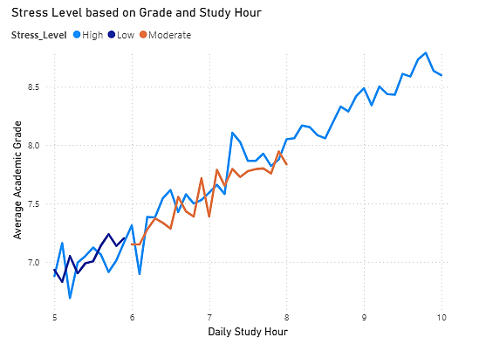
All stress groups show grades improving as study hours increase. At any level of study hours, students with Low stress have higher average grades than those with Moderate or High stress.
- The gap between stress levels widens as study hours increase: More study hours benefit all groups, but students with Low stress gain the most in academic performance.

- Is there any relationship between physical activity and stress levels among students?
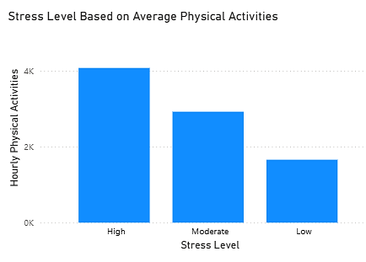
There is an inverse relationship: students who are more physically active tend to report lower stress. Students with high stress are, on average, less physically active.

- Analyze if students with higher social interaction hours perform better or worse in academics.
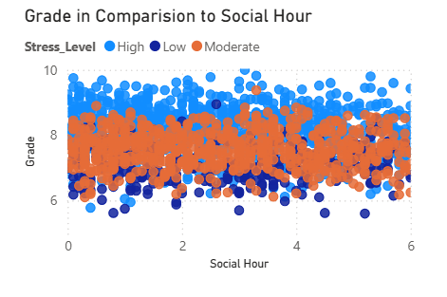
Students with higher social interaction hours do NOT consistently perform better or worse in academics. Performance appears largely independent of social hours, regardless of stress level.
- Explore whether extracurricular involvement contributes positively or negatively to academic grades.
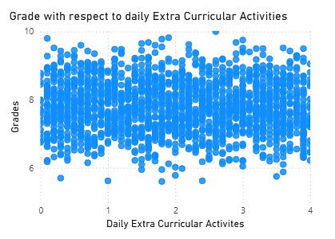
The data points are spread without any upward or downward trend. Students with both low and high extracurricular hours have grades across the full range. There is no visible positive or negative relationship between extracurricular involvement and academic grades in this dataset.

- Evaluate how sleep patterns vary with gender and how this variation reflects in their grades.
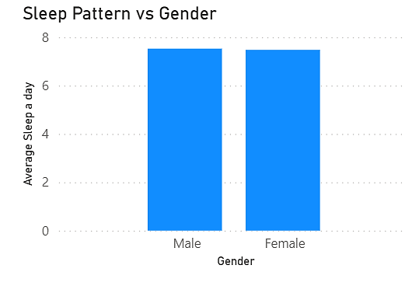
Average sleep per day is nearly identical for both male and female students.There is no meaningful difference in average sleep patterns by gender in this dataset.

- Do students with higher physical activity tend to sleep more or less than others?
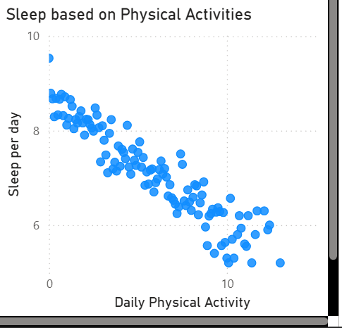
There is a clear negative correlation: as physical activity hours per day increase, sleep hours per day decrease. Students with higher physical activity tend to sleep less than others.

- Examine if students with a high stress level have lower, equal, or higher academic performance compared to others.
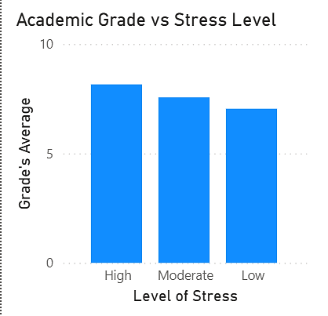
In this dataset, higher stress levels are associated with higher academic performance. Students with high stress outperform both moderate and low stress groups academically.

- Assess if students from a particular gender exhibit more balanced time allocation across study, social, and extracurricular activities.
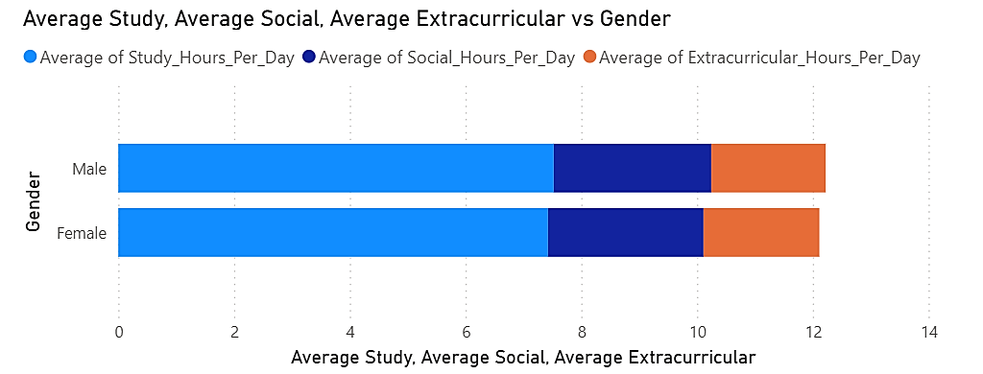
Both genders allocate their daily time across study, social, and extracurricular activities in a nearly identical and balanced way. No gender exhibits a clearly more balanced time allocation than the other.

- Investigate which variable(s) most strongly correlate with grades and provide your analysis.
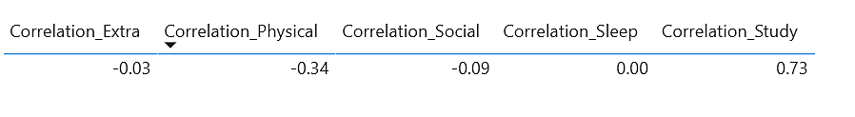
Increasing study time is most strongly associated with higher academic performance in this dataset.

- Determine if students who spend less time on social activities compensate with better grades.
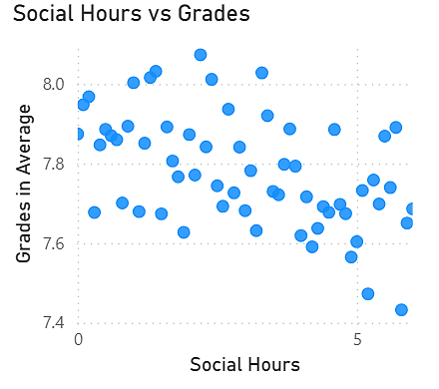
Students who spend less time on social activities tend to have slightly better grades. However, the effect is weak not all students with low social hours have high grades, but the downward trend is present.
Section 2: Case Study with What-If Analysis
- Which factor(s) should the counselor prioritize when advising students to improve academic performance while reducing stress?
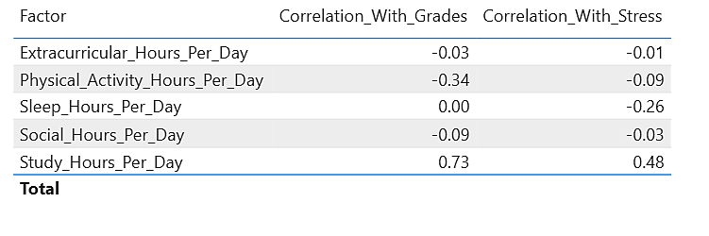
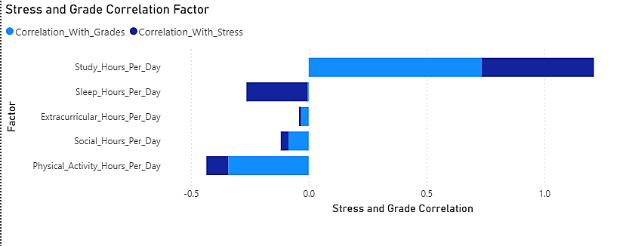
- Study_Hours_Per_Day has by far the strongest positive correlation with Grades (0.73), meaning more study strongly improves academic performance.
- Study_Hours_Per_Day is also the only factor with a moderately positive correlation with Stress (0.48), meaning more study is associated with higher stress, not reduced stress.
- Sleep_Hours_Per_Day has a low (nearly zero) effect on Grades, but a moderate negative correlation with Stress (-0.26), meaning more sleep is associated with reduced stress, but has no effect on grades.

- Identify the top 3 habits common among the highest scoring students. Would you recommend the same habits to everyone? Justify your reasoning.
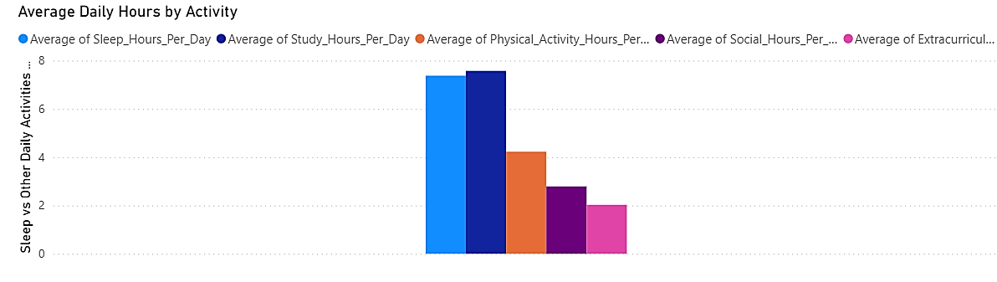
Top 3 habits among the highest scoring students:
Sleep_Hours_Per_Day
Study_Hours_Per_Day
Physical_Activity_Hours_Per_Day
So, I would not recommend this habit to everyone without qualification.
- Study_Hours_Per_Day: Our previous analysis proved that while more study hours strongly improve grades, they also increase stress. Recommending more study hours for everyone increases risk of burnout for some students.
- Sleep_Hours_Per_Day: Higher sleep is associated with reduced stress and no negative impact on grades. This should be universally recommended.
- Physical_Activity_Hours_Per_Day: If our correlation analysis does not show a strong negative impact, this is generally safe to promote.

- Segment the students into three clusters based on their lifestyle habits (study, sleep, extracurricular, physical activity). Which cluster demonstrates the best performance, and why?
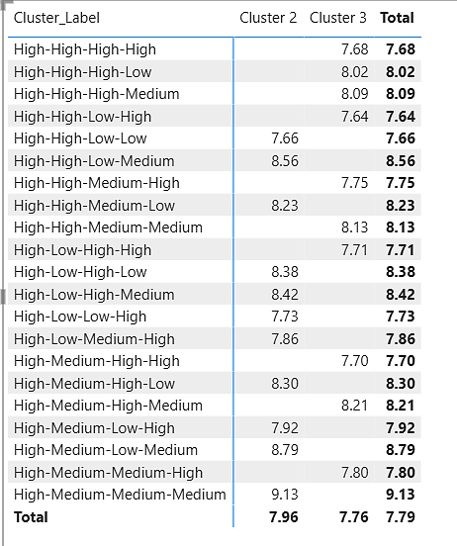
Best performance is seen in cluster ‘High-Medium-Medium-Medium’.
Reason:
- This cluster is defined by high study hours, medium sleep hours, medium extracurricular activity, and medium physical activity.
- Among all clusters, this combination results in the highest average grades.

- What recommendations would you provide to students who have a stress level marked “High” but also want to maintain good grades?
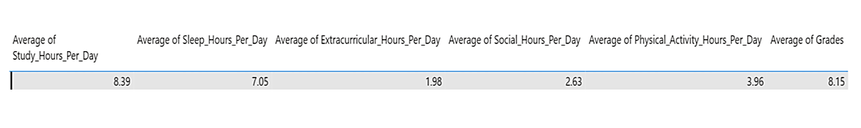
Recommendations:
- Maintain high study hours (around 8.4/day) if the goal is top grades but ONLY if you can also sustain adequate rest and activity.
- Prioritize at least 7 hours of sleep daily.
- Do not cut sleep to increase study this group does NOT do that, and your clusters confirm less sleep does not boost grades.
- Incorporate physical activity (approx. 4 hours/day) and moderate extracurricular and social engagement.
- Balanced, active routines (not just “all study”) support good grades even for high-stress students.
- Strictly, do NOT try to increase study hours further or drop other activities; more study at the expense of sleep or activity will probably raise stress without improving grades.

- If a student increases their study hours by 1 hour and decreases social time by 1 hour, what potential impact might this have on their academic performance?
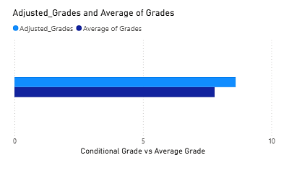
If a student increases their study hours by 1 hour and decreases their social time by 1 hour, my analysis shows that their academic performance is likely to improve. The average grade increases in this scenario, as demonstrated in my comparison chart between actual and adjusted grades. This is because study hours have a strong positive correlation with grades in my dataset, while social hours have almost no impact on academic results. Therefore, shifting 1 hour from social activities to studying is expected to raise grades, according to the evidence in my data. However, I also note that reducing social time too much or raising study hours excessively could affect stress and well-being, which are not measured by grades alone.

- Analyze how shifting 1 hour from sleep to physical activity affects the overall stress level and grade of students.
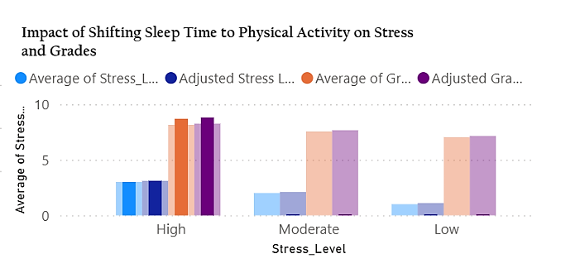
If we shift 1 hour per day from sleep to physical activity, the impact on students’ stress levels and grades is:
- Stress Level:
- The adjusted stress bars are higher across all stress groups (“High”, “Moderate”, “Low”).
- This means overall stress increases for all students when sleep is reduced by 1 hour and physical activity is increased by 1 hour.
- The increase in stress from losing sleep is not fully offset by the stress-reducing effect of more physical activity.
Grades:
The adjusted grade bars either stay about the same or decrease slightly compared to the original.
This shows grades do not improve with this shift, and may even drop a little, especially in the “High” stress group.

